 **NIMS COLLEGE**

Registration No: 6-2-756-08-2019

(Tribhuvan University)

*Kanibahal, Lalitpur*

Case Study

of

Operating System

Submitted by Submitted To

Raj kumar karki Suraj sha

Semester: 4th  BCA (Bachelor in Computer Application)

**CASE STUDY**

**Windows Operating System:**

**Microsoft Windows is** also called **Windows** and **Windows OS.** Windows [operating system](https://www.britannica.com/technology/operating-system) (OS) developed by [Microsoft Corporation](https://www.britannica.com/topic/Microsoft-Corporation) to run [personal computers](https://www.britannica.com/technology/personal-computer) (PCs). Featuring the first [graphical user interface](https://www.britannica.com/technology/graphical-user-interface) (GUI) for [IBM](https://www.britannica.com/topic/International-Business-Machines-Corporation)-compatible PCs, the Windows OS soon dominated the PC market. Approximately 90 percent of PCs run some version of Windows.

The first version of Windows, released in 1985, was simply a GUI offered as an [extension](https://www.britannica.com/technology/plug-in) of Microsoft’s existing disk operating system, or [MS-DOS](https://www.britannica.com/technology/MS-DOS). Based in part on licensed concepts that [Apple Inc.](https://www.britannica.com/topic/Apple-Inc) had used for its Macintosh System Software, Windows for the first time allowed DOS users to visually navigate a virtual desktop, opening graphical “windows” displaying the contents of electronic folders and files with the click of a [mouse](https://www.britannica.com/technology/mouse-computer-device) button, rather than typing commands and directory paths at a text prompt.

Subsequent versions introduced greater functionality, including native Windows File Manager, Program Manager, and Print Manager programs, and a more [dynamic](https://www.merriam-webster.com/dictionary/dynamic) interface. Microsoft also developed specialized Windows packages, including the networkable Windows for Workgroups and the high-powered Windows NT, aimed at businesses. The 1995 consumer release Windows 95 fully [integrated](https://www.merriam-webster.com/dictionary/integrated) Windows and DOS and offered built-in [Internet](https://www.britannica.com/technology/Internet) support, including the [World Wide Web](https://www.britannica.com/topic/World-Wide-Web) [browser](https://www.britannica.com/technology/browser) [Internet Explorer](https://www.britannica.com/technology/Internet-Explorer).

With the 2001 release of [Windows XP](https://www.britannica.com/technology/Windows-XP), Microsoft united its various Windows packages under a single banner, offering multiple editions for consumers, businesses, multimedia developers, and others. Windows XP abandoned the long-used Windows 95 kernel (core [software](https://www.britannica.com/technology/software) code) for a more powerful code base and offered a more practical interface and improved application and memory management. The highly successful XP standard was succeeded in late 2006 by Windows Vista, which experienced a troubled rollout and met with considerable marketplace resistance, quickly acquiring a reputation for being a large, slow, and resource-consuming system. Responding to Vista’s disappointing adoption rate, Microsoft in 2009 released [Windows 7](https://www.britannica.com/technology/Windows-7), an OS whose interface was similar to that of [Vista](https://www.britannica.com/dictionary/Vista) but was met with enthusiasm for its noticeable speed improvement and its modest system requirements.

[Windows 8](https://www.britannica.com/technology/Windows-8) in 2012 offered a start screen with applications appearing as tiles on a grid and the ability to synchronize settings so users could log on to another Windows 8 [machine](https://www.britannica.com/technology/machine) and use their preferred settings. In 2015 Microsoft released [Windows 10](https://www.britannica.com/technology/Windows-10), which came with [Cortana](https://www.britannica.com/topic/Cortana), a digital personal assistant like [Apple](https://www.britannica.com/topic/Apple-Inc)’s Siri, and the Web browser Microsoft Edge, which replaced Internet Explorer. Microsoft also announced that Windows 10 as the last version of Windows which means that users would receive regular updates to the OS but that no more large-scale revisions would be done. But again Windows 11 is the latest major release of Microsoft's Windows NT operating system and it was released in October 2021. It is a free upgrade to its predecessor, Windows 10, available for any Windows 10 devices that meet the new Windows 11 system requirements.

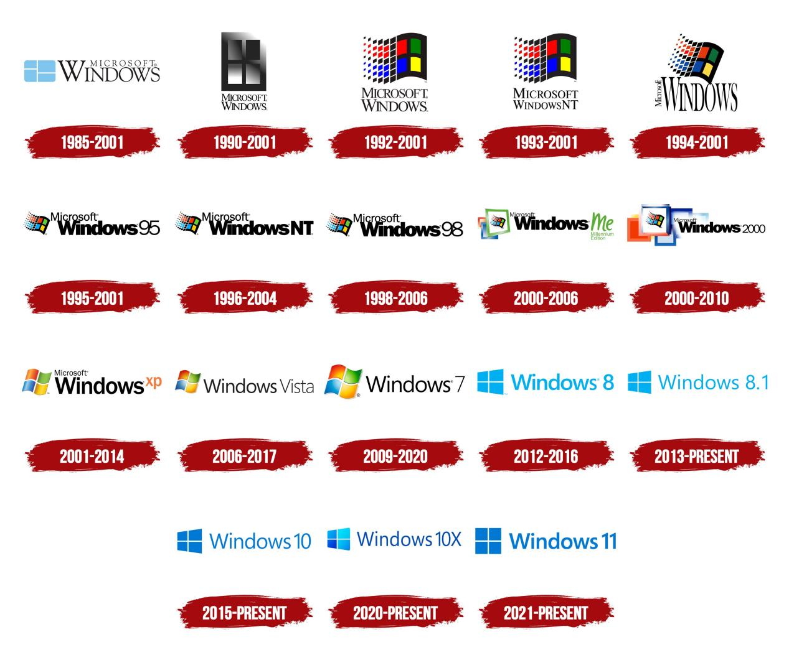

Fig : Evolution of Windows Operating System from 1985 to present

**DOS Operating System:**

**MS-DOS stands for Microsoft Disk Operation System.** The dominant [operating system](https://www.britannica.com/technology/operating-system) for the [personal computer](https://www.britannica.com/technology/personal-computer) (PC) throughout the 1980s. The acquisition and marketing of MS-DOS were pivotal in the [Microsoft Corporation](https://www.britannica.com/topic/Microsoft-Corporation)’s transition to [software](https://www.britannica.com/technology/software) industry giant.

American computer programmer Timothy Paterson, a developer for Seattle Computer Products, wrote the original operating system for the [Intel Corporation](https://www.britannica.com/topic/Intel)’s 8086 [microprocessor](https://www.britannica.com/technology/microprocessor) in 1980, initially calling it QDOS (Quick and Dirty Operating System), which was soon renamed 86-DOS. A year later, fledgling company Microsoft purchased [exclusive](https://www.merriam-webster.com/dictionary/exclusive) rights to sell the system, renamed MS-DOS, to [IBM](https://www.britannica.com/topic/International-Business-Machines-Corporation) for their newly developed IBM-PC. IBM-compatible versions were marketed as PC-DOS. Version 1.0 was released in 1981; additional upgraded versions kept pace with the rapidly evolving PC. Windows 95, introduced by Microsoft in 1995, incorporated MS-DOS 7.0 but ultimately superseded the MS-DOS platform. Starting with Windows NT, Microsoft’s operating systems were designed independently of MS-DOS, though they were capable of running some MS-DOS applications.

Although MS-DOS enjoyed enormous popularity in the 1980s and early 1990s, the [technology](https://www.britannica.com/technology/technology) did not always keep pace with its competition. The system lacked the [multitasking](https://www.britannica.com/technology/multitasking), multiuser [capabilities](https://www.britannica.com/dictionary/capabilities) of the [UNIX](https://www.britannica.com/technology/UNIX) operating system; and MS-DOS was limited to a command line interface, in contrast to the user-friendly [graphical user interface](https://www.britannica.com/technology/graphical-user-interface) (GUI) of the early Macintosh computer from [Apple Inc.](https://www.britannica.com/topic/Apple-Inc) Although MS-DOS ceased to be marketed as a stand-alone operating system, the relatively simple, stable platform is still used in some embedded computer systems.

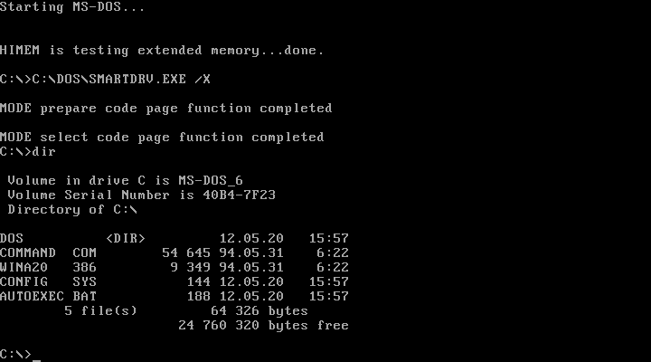

Fig: DOS

| MS-DOS Command List | |
| --- | --- |
| Command | Description |
| Append | The append command can be used by programs to open files in another directory as if they were located in the current directory. |
| Assign | The assign command is used to redirect drive requests to a different drive. This command can also show drive assignments and reset drive letters to their original assignments. |
| Attrib | The [attrib command](https://www.lifewire.com/attrib-command-2625802) is used to change the attributes of a single file or a directory. |
| Break | The break command sets or clears extended CTRL+C checking on DOS systems. |
| Call | The call command is used to run a script or batch program from within another script or batch program. The call command has no effect outside of a script or batch file. In other words, running the call command at the MS-DOS prompt will do nothing. |
| Cd | The cd command is the shorthand version of the chdir command. |
| Chcp | The chcp command displays or configures the active code page number. |
| Chdir | The chdir command is used to display the drive letter and folder that you are currently in. Chdir can also be used to change the drive and/or directory that you want to work in. |
| Chkdsk | The [chkdsk command](https://www.lifewire.com/chkdsk-command-2625838), often referred to as check disk, is used to identify and correct certain [hard drive errors](https://www.lifewire.com/check-and-fix-hard-drive-errors-3506860). |
| Choice | The choice command is used within a script or batch program to provide a list of choices and return the value of that choice to the program. |
| Cls | The cls command clears the screen of all previously entered commands and other text. |
| Command | The command command starts a new instance of the command.com command interpreter. |
| Copy | The [copy command](https://www.lifewire.com/copy-command-2625842) copies one or more files from one location to another. |
| Country | The country command is used in the CONFIG.SYS file to tell MS-DOS to use country-specific text conventions during processing. |
| Ctty | The ctty command is used to change the default input and output devices for the system. |
| Date | The date command is used to show or change the current date. |
| Dblspace | The dblspace command is used to create or configure DoubleSpace compressed drives. |
| Debug | The debug command starts Debug, a command line application used to test and edit programs. |
| Defrag | The defrag command is used to defragment a drive you specify. The defrag command is the command line version of Microsoft's Disk Defragmenter. |
| Del | The [del command](https://www.lifewire.com/delete-command-2625859) is used to delete one or more files. The del command is the same as the erase command. |
| Deltree | The deltree command is used to delete a directory and all the files and subdirectories within it. |
| Device | The device command is used in the CONFIG.SYS file to load device drivers into memory. |
| Devicehigh | The devicehigh command is used in the CONFIG.SYS file to load device drivers into upper memory. |
| Dir | The [dir command](https://www.lifewire.com/dir-command-4050018) is used to display a list of files and folders contained inside the folder that you are currently working in. The dir command also displays other important information like the hard drive's [serial number](https://www.lifewire.com/serial-number-2626008), the total number of files listed, their combined size, the total amount of free space left on the drive, and more. |
| Diskcomp | The diskcomp command is used to compare the contents of two floppy disks. |
| Diskcopy | The diskcopy command is used to copy the entire contents of one floppy disk to another. |
| Dos | The dos command is used in the CONFIG.SYS file to specify the memory location for DOS. |
| Doskey | The doskey command is used to edit command lines, create macros, and recall previously entered commands. |
| Dosshell | The dosshell command starts DOS Shell, a graphical file management tool for MS-DOS. The dosshell command was only available up to MS-DOS 6.0 but most MS-DOS 6.22 installations were upgrades from previous versions so the dosshell command is usually still available. |
| Drvspace | The drvspace command is used to create or configure DriveSpace compressed drives. DriveSpace, executed using the drvspace command, is an updated version of DoubleSpace. DriveSpace is an updated version of DoubleSpace, executed using the dblspace command. |
| Echo | The echo command is used to show messages, most commonly from within script or batch files. The echo command can also be used to turn the echoing feature on or off. |
| Edit | The edit command starts the MS-DOS Editor tool, which is used to create and modify [text files](https://www.lifewire.com/txt-text-file-4150707). |
| Edlin | The edlin command starts the Edlin tool, which is used to create and modify text files from the command line. Edlin was only available up to MS-DOS 5.0 so unless your version of MS-DOS 6.22 was upgraded from 5.0, you likely won't see the edlin command. |
| Emm386 | The emm386 command is used to give MS-DOS access to more than 640 KB of memory. |
| Exe2bin | The exe2bin command is used to convert .EXE files to binary format. |
| Erase | The erase command is used to delete one or more files. The erase command is the same as the del command. |
| Exit | The exit command is used to end the command.com session that you're currently working in. |
| Expand | The expand command is used to extract the files and folders contained in Microsoft Cabinet (CAB) files. |
| Fasthelp | The fasthelp command provides more detailed information on any of the other MS-DOS commands. |
| Fastopen | The fastopen command is used to add a program's hard drive location to a special list stored in memory, potentially improving the program's launch time by removing the need for MS-DOS to locate the application on the drive. |
| Fc | The fc command is used to compare two individual or sets of files and then show the differences between them. |
| Fcbs | The fcbs command is used in the CONFIG.SYS file to specify the number of file-control blocks for file sharing. |
| Fdisk | The fdisk command is used to create, manage, and delete hard drive [partitions](https://www.lifewire.com/what-is-a-partition-2625958). |
| Files | The files command is used in the CONFIG.SYS file to specify the maximum number of files that can be open at the same time. |
| Find | The find command is used to search for a specified text string in one or more files. |
| For | The for command is used to run a specified command for each file in a set of files. The for command is most often used within a batch or script file. |
| Format | The [format command](https://www.lifewire.com/format-command-2618091) is used to format a drive in the file system that you specify. |
| Goto | The goto command is used in a batch or script file to direct the command process to a labeled line in the script. |
| Graphics | The graphics command is used to load a program that can print graphics. |
| Help | The [help command](https://www.lifewire.com/help-command-2618092) provides more detailed information on any of the other Command Prompt or MS-DOS commands. |
| If | The if command is used to perform conditional functions in a batch file. |
| Include | The include command is used in the CONFIG.SYS file to allow you to use the commands from one CONFIG.SYS block within another. |
| Install | The install command is used in the CONFIG.SYS file to load memory-resident programs into conventional memory. |
| Interlnk | The interlnk command is used to connect two computers via a serial or parallel connection to share files and printers. |
| Intersvr | The intersvr command is used to start the Interlnk server and to copy Interlnk files from one computer to another. |
| Join | The join command is used to attach a drive letter to a directory located on another drive. It's similar to the subst command which associates a drive letter with a local directory. |
| Keyb | The keyb command is used to configure a keyboard for a specific language. |
| Label | The label command is used to manage the [volume label](https://www.lifewire.com/volume-label-2626045) of a disk. |
| Lastdrive | The lastdrive command is used in the CONFIG.SYS file to set the maximum number of drives that can be accessed. |
| Lh | The lh command is the shorthand version of the loadhigh command. |
| Loadfix | The loadfix command is used to load the specified program in the first 64K of memory and then runs the program. |
| Loadhigh | The loadhigh command is used to load a program into high memory and is usually used from within the autoexec.bat file. |
| Md | The md command is the shorthand version of the mkdir command. |
| Mem | The mem command shows information about used and free memory areas and programs that are currently loaded into memory in the MS-DOS subsystem. |
| Memmaker | The memmaker command is used to start MemMaker, a memory optimization tool. |
| Menucolor | The menucolor command is used in the CONFIG.SYS file to set text colors. |
| Menudefault | The menudefault command is used in the CONFIG.SYS file to set the startup configuration that will be used if no key is pressed within the specified timeout period. |
| Menuitem | The menuitem command is used in the CONFIG.SYS file to create a startup menu from which you can select a group of CONFIG.SYS commands to be processed upon reboot. |
| Mkdir | The mkdir command is used to create a new folder. |
| Mode | The mode command is used to configure system devices, most often COM and LPT ports. |
| More | The [more command](https://www.lifewire.com/more-command-4041467) is used to display the information contained in a text file. The more command can also be used to paginate the results of any other Command Prompt or MS-DOS command. |
| Move | The move command is used to move one or files from one folder to another. The move command is also used to rename directories. |
| Msav | The msav command starts Microsoft Antivirus. |
| Msbackup | The msbackup command starts Microsoft Backup, a tool used to back up and restore one or more files. |
| Mscdex | The mscdex command is used to provide CD-ROM access to MS-DOS. |
| Msd | The msd command starts Microsoft Diagnostics, a tool used to display information about your computer. |
| Nlsfunc | The nlsfunc command is used to load information specific to a particular country or region. |
| Numlock | The numlock command is used in the CONFIG.SYS file to specify the state of the NumLock key. |
| Path | The path command is used to display or set a specific path available to executable files. |
| Pause | The pause command is used within a batch or script file to pause the processing of the file. When the pause command is used, a "Press any key to continue…" message displays in the command window. |
| Power | The power command is used to reduce the power consumed by a computer by monitoring software and hardware devices. |
| Print | The print command is used to print a specified text file to a specified printing device. |
| Prompt | The prompt command is used to customize the appearance of the prompt text in Command Prompt or MS-DOS. |
| Qbasic | The qbasic command starts QBasic, the MS-DOS based programming environment for the BASIC programming language. |
| Rd | The rd command is the shorthand version of the rmdir command. |
| Rem | The rem command is used to record comments or remarks in a batch or script file. |
| Ren | The [ren command](https://www.lifewire.com/rename-command-2625993) is the shorthand version of the rename command. |
| Rename | The rename command is used to change the name of the individual file that you specify. |
| Replace | The replace command is used to replace one or more files with one or more other files. |
| Restore | The restore command is used to restore files that were backed up using the backup command. The backup command was only available up to MS-DOS 5.00 but the restore command was included by default with later versions of MS-DOS to provide a way to restore files that were backed up in previous versions of MS-DOS. |
| Rmdir | The rmdir command is used to delete an existing or completely empty folder. |
| Scandisk | The scandisk command is used to start Microsoft ScanDisk, a disk repair program. |
| Set | The set command is used to display, enable, or disable [environment variables](https://www.lifewire.com/what-are-environment-variables-2625868) in MS-DOS or from the Command Prompt. |
| Setver | The setver command is used to set the MS-DOS [version number](https://www.lifewire.com/version-number-2626043) that MS-DOS reports to a program. |
| Share | The share command is used to install file locking and file sharing functions in MS-DOS. |
| Shell | The shell command is used in the CONFIG.SYS file to specify the command interpreter that DOS should use. |
| Shift | The shift command is used to change the position of replaceable parameters in a batch or script file. |
| Smartdrv | The smartdrv command installs and configures SMARTDrive, a disk caching utility for MS-DOS. |
| Sort | The sort command is used to read data from a specified input, sort that data, and return the results of that sort to the Command Prompt screen, a file, or another output device. |
| Stacks | The stacks command is used in the CONFIG.SYS file to set the number and size of stack frames. |
| Submenu | The submenu command is used in the CONFIG.SYS file to create a multi-level menu from which you can select startup options. |
| Subst | The subst command is used to associate a local path with a drive letter. The subst command is a lot like the [net use command](https://www.lifewire.com/net-use-command-2618096) in Windows except a local path is used instead of a shared network path. The subst command replaced the assign command beginning with MS-DOS 6.0. |
| Switches | The switches command is used in the CONFIG.SYS file to configure DOS in a special way, like to tell DOS to emulate different hardware configurations. |
| Sys | The sys command is used to copy the MS-DOS system files and command interpreter to a disk. The sys command is used most often to create a simple bootable disk or hard drive. |
| Time | The time command is used to show or change the current time. |
| Tree | The tree command is used to graphically display the folder structure of a specified drive or path. |
| Type | The type command is used to display the information contained in a text file. |
| Undelete | The undelete command is used to undo a deletion performed with the MS-DOS delete command. |
| Unformat | The unformat command is used to undo the formatting on a drive performed by the MS-DOS format command. |
| Ver | The ver command is used to display the current MS-DOS version number. |
| Verify | The verify command is used to enable or disable the ability of Command Prompt, or MS-DOS, to verify that files are written correctly to a disk. |
| Vol | The [vol command](https://www.lifewire.com/vol-command-2618102) shows the volume label and a serial number of a specified disk, assuming this information exists. |
| Vsafe | The vsafe command is used to start VSafe, a basic virus protection system for MS-DOS. |
| Xcopy | The [xcopy command](https://www.lifewire.com/xcopy-command-2618103) can copy one or more files or directory trees from one location to another. The xcopy command is generally considered a more "powerful" version of the copy command though the robocopy command trumps even xcopy. |

**Linux Operating System:**

**Linux** [operating system](https://www.britannica.com/technology/operating-system) created in the early 1990s by Finnish software engineer [Linus Torvalds](https://www.britannica.com/biography/Linus-Torvalds) and the [Free Software Foundation](https://www.britannica.com/topic/Free-Software-Foundation) (FSF).

While still a student at the University of Helsinki, Torvalds started developing Linux to create a system similar to MINIX, a [UNIX](https://www.britannica.com/technology/UNIX) operating system. In 1991 he released version 0.02; Version 1.0 of the Linux kernel, the core of the operating system, was released in 1994. About the same time, American software developer [Richard Stallman](https://www.britannica.com/biography/Richard-Stallman) and the FSF made efforts to create an [open-source](https://www.britannica.com/topic/open-source) UNIX-like operating system called GNU. In contrast to Torvalds, Stallman and the FSF started by creating utilities for the operating system first. These utilities were then added to the Linux kernel to create a complete system called GNU/Linux, or, less precisely, just Linux.

Linux grew throughout the 1990s because of the efforts of hobbyist developers. Although Linux is not as user-friendly as the popular [Microsoft Windows](https://www.britannica.com/technology/Windows-OS) and [Mac OS](https://www.britannica.com/technology/Mac-OS) operating systems, it is an efficient and reliable system that rarely crashes. Combined with [Apache](https://www.britannica.com/technology/Apache-Web-server), an open-source Web [server](https://www.britannica.com/technology/server), Linux accounts for most of the [servers](https://www.britannica.com/technology/server) used on the [Internet](https://www.britannica.com/technology/Internet). Because it is open-source, and thus modifiable for different uses, Linux is popular for systems as [diverse](https://www.merriam-webster.com/dictionary/diverse) as [cellular telephones](https://www.britannica.com/technology/mobile-telephone) and [supercomputers](https://www.britannica.com/technology/supercomputer). [Android](https://www.britannica.com/technology/Android-operating-system), [Google](https://www.britannica.com/topic/Google-Inc)’s operating system for mobile devices, has at its core a modified Linux kernel, and Chrome OS, Google’s operating system that uses the Chrome [browser](https://www.britannica.com/technology/browser), is also Linux-based. The addition of user-friendly desktop [environments](https://www.merriam-webster.com/dictionary/environments), office suites, Web [browsers](https://www.britannica.com/technology/browser), and even games helped to increase Linux’s popularity and make it more suitable for home and office desktops. New distributions (packages of Linux software) have been created since the 1990s. Some of the more well-known distributions include MX Linux, Manjaro, Linux Mint, and Ubuntu.

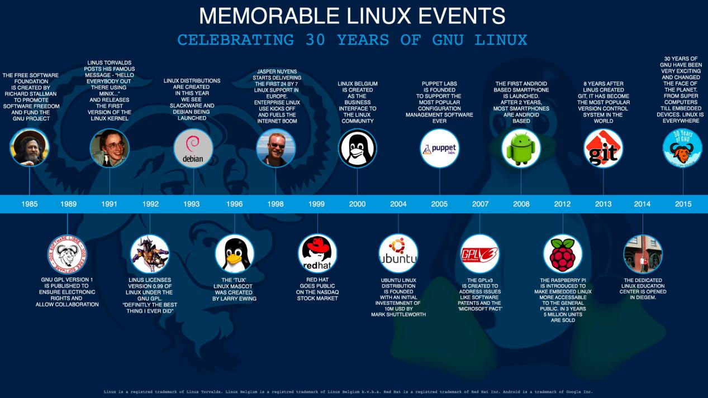

Fig: Linux events

**Unix Operating System:**

**UNIX is the** multiuser computer [operating system](https://www.britannica.com/technology/operating-system). In the late 20th century UNIX was widely used for [Internet](https://www.britannica.com/technology/Internet) servers, [workstations](https://www.britannica.com/technology/workstation), and [mainframe computers](https://www.britannica.com/technology/mainframe). The main features of UNIX were its [simplicity](https://www.britannica.com/dictionary/simplicity), portability (the ability to run on many different systems), [multitasking](https://www.britannica.com/technology/multitasking) and multiuser capabilities, extensive library of [software](https://www.britannica.com/technology/software), and hierarchical file system.

UNIX was developed by [AT&T Corporation](https://www.britannica.com/topic/ATandT-Corporation)’s [Bell Laboratories](https://www.britannica.com/topic/Bell-Laboratories) in the late 1960s as a result of efforts to create a [time-sharing](https://www.britannica.com/technology/time-sharing) [computer](https://www.britannica.com/technology/computer) system. In 1969 a team led by computer scientists [Ken Thompson](https://www.britannica.com/biography/Kenneth-Lane-Thompson) and [Dennis Ritchie](https://www.britannica.com/biography/Dennis-M-Ritchie) created the first version of UNIX on a PDP-7 minicomputer, which was chosen mainly because of Thompson’s familiarity with the system from his hobby work on it. (The name UNIX was a pun on Multics, an earlier time-sharing operating system project at Bell Laboratories.) UNIX was quickly adapted for another computer, and the team ported (modified) it to the PDP-11 by late 1970. This would be the first of many ports of UNIX.

Thompson left Bell Laboratories for a while and taught a course on UNIX at the [University of California](https://www.britannica.com/topic/University-of-California) at Berkeley in the mid-1970s. Students and professors there further [enhanced](https://www.merriam-webster.com/dictionary/enhanced) UNIX, eventually creating a version of UNIX called Berkeley Software Distribution (BSD). Work at AT&T also continued, leading to the 1983 release of a new version of UNIX called System V. These versions were later joined by UNIX versions created by [Sun Microsystems, Inc.](https://www.britannica.com/topic/Sun-Microsystems-Inc), and [Silicon Graphics, Inc.](https://www.britannica.com/topic/SGI), among other companies, and continued development kept UNIX on pace with improvements in computer [technology](https://www.britannica.com/technology/technology). UNIX served as the inspiration for many subsequent free [open-source](https://www.britannica.com/topic/open-source) operating systems such as FreeBSD and [Linux](https://www.britannica.com/technology/Linux) (which largely replaced UNIX), and it was the basis for [Apple Inc.](https://www.britannica.com/topic/Apple-Inc)’s [Mac OS](https://www.britannica.com/technology/Mac-OS) X.



Fig: Unix Operating System